Course Introduction
Contents:
- What do we mean by computer systems?
- The computer hierarchy
- How to measure a computer system
- The von Neumann Architecture

What do we mean by computer systems?

Computer Organisation
- Encompasses all physical aspects of computer systems.
- How does a computer work?
Computer Architecture
- Logical aspects of system implementation as seen by the programmer.
- How is a computer designed?

At the most basic level, a computer is a device consisting of three components.
- A processor to interpret and execute programs
- A memory to store data and/or programs
- A mechanism for transferring data to and from the outside world (input/output devices)

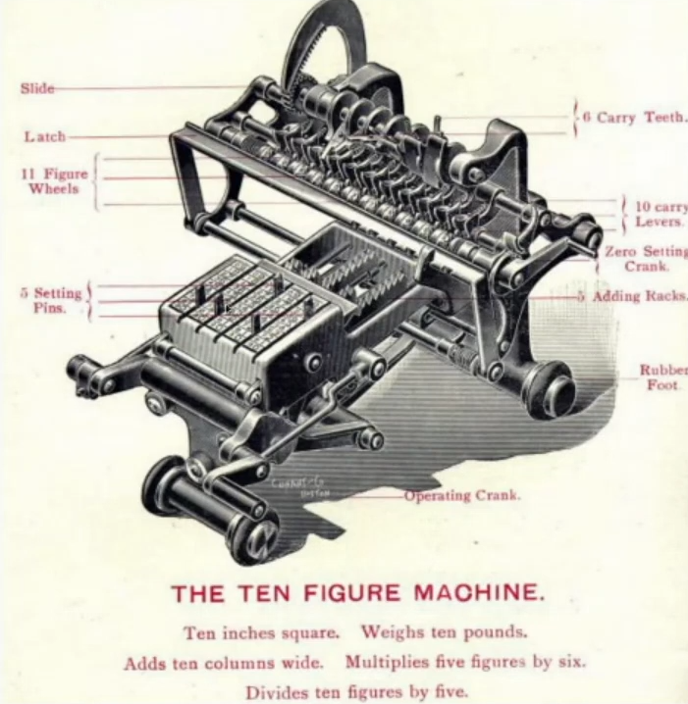
Computer systems can range in complexity and size, from supercomputers to smart lightbulbs, or toilet roll holders.

Computers precede the invention of electricity. An example is this mechanical calculator. However, there are still modern day examples of mechanical systems, like an egg timer.

The computer level hierarchy
There are seven levels to computer level hierarchy, ranging in abstraction levels (physical detail).
- The highest level is the most abstract
- The lowest level is the least abstract
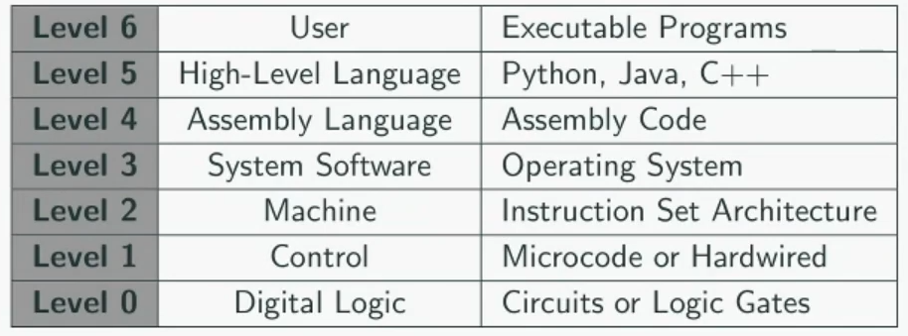
You can imagine that we are passing down instructions through these levels, and then outputted through these levels.
Level 6: User Level
- The applications level, which users typically interact with a computer.
- At this level, we run programs like internet browsers, graphics editors and games.
- It is almost impossible to be able to understand how a computer does something (e.g.: move a character a number of spaces)
Level 5: High-Level Language Level
- The level with which we interact when we write programs in languages such as Python, Java and C++
- Programs written in high-level languages must first be compiled or interpreted, and then assembled before they can be executed.
- You are still quite removed from interacting with the computer directly.
Level 4: Assembly Language Level
- High-level program instructions are translated into assembly language instructions.
- These instructions can be translated one-to-one into instructions at the machine level.
- Programs used to be written in this language.
Level 3: System Software Level
- Controls (multiple) executing processes on the system.
- Protects system resources (e.g. from buggy or malicious programs)
- On modern personal computers, these are typically complex systems called Operating Systems.
- It is the role of the system software for the management of resources. Before any instructions are executed, they must be passed through this level to ensure the instruction is safe to execute.
Level 2: Machine Level (Instruction Set Architecture)
- Consists of instructions that are particular to this architecture of the machine.
- Programs written in machine language need no compilers, interpreters or assemblers.
- Unless you have the exact same hardware, these instructions can not be interchanged through different computer systems.
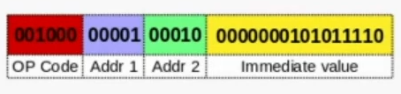

Level 1: Control Level
- A control unit decodes and executes instructions, typically the CPU.
- Control units can be microprogrammed or hardwired.
  - Microprogrammed control units are written in a low-level language that is implemented by the hardware (general PCs)
  - Hardwired control units consist of hardware that directly executes machine instructions. (embedded systems)
Level 0: Digital Logic
- This is where we find the digital circuits and microchips.
- Digital circuits consist of gates and wires.
- These physical components (e.g. transistors and resistors) implement the mathematical logic of all other levels.

How to measure a computer
The Central Processing Unit
- This relates to how fast executions can be completed
- This is measured in frequency in Hertz (Hz)
The Memory
- This relates to how much can be stored
- This is measured in bytes (B)

We use SI prefixes to talk about these numbers at the extreme scale.
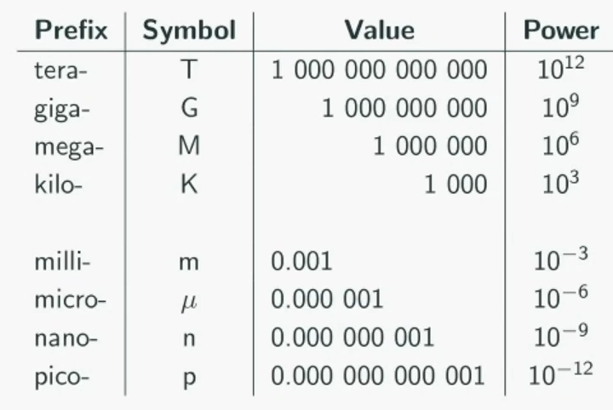

e.g.:
- 4.0 GHz = 4x10⁹ Hz = 4,000,000,000 Hz
- 7895 MB = 7.895 GB = 7895x10⁶ B = 7,895,000,000 B
- 14 ns = 14x10⁻⁹ = 0.000000014 s

So what’s MiB?
- Typically, it’s more accurate to measure memory in powers of 2 rather than powers of 10. Therefore, “i” is used for powers of 2.
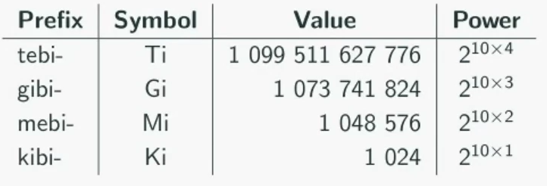

The von Neumann Model
The majority of modern day computer systems use this model.
- In the earliest of electronic computers, programming was connecting wires to plugs.
- Nowadays, programs aren’t written by changing the physical layout of the computer hardware. Instead, programs are stored as a series of instructions in computer memory.
- On top of the three components of a computer (CPU, memory, I/O), the von Neumann model also specifies:
  - The capacity to carry out sequential instruction processing
  - A single data path between the CPU and main memory (von Neumann bottleneck)
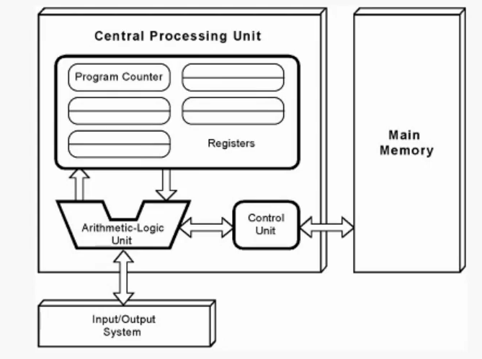

The main memory stores the instructions and data used in processing.
The central processing unit consists of multiple sub components.
- The control unit is responsible for translating the instructions for the processor to understand.
- The ALU undertakes the steps of computation.
- The registers holds data and instructions.
  - Namely, the program counter keeps track of the next instruction to be executed.
It is then outputted through the output system.

The computer undergoes the fetch, decode, execute cycle per instruction.
- At the start of the, the control unit fetches the next instruction from memory and updates the program counter to determine where the next instruction is located. It gets the address of the next instruction from the program counter.
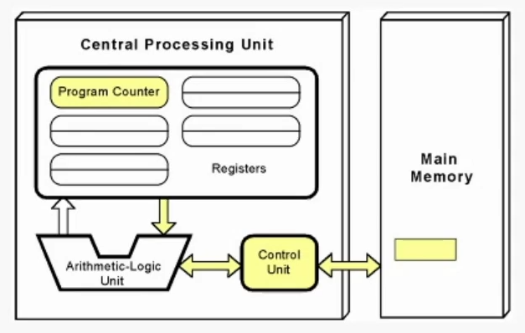

- The instruction is then translated into a form the ALU can understand
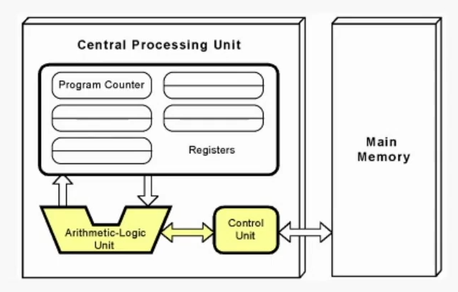

- It is then executed. Any data required is loaded into the registers.
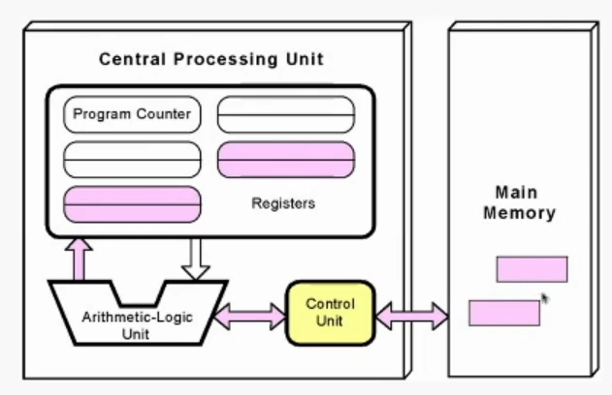

- The results are then stored in main memory or registers.
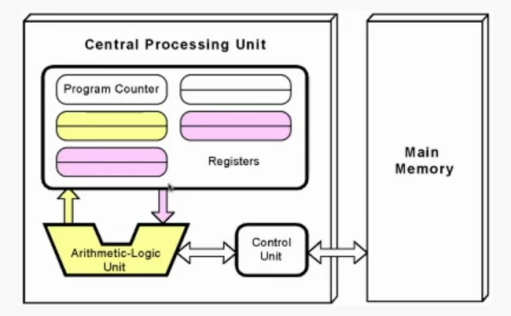

There is a disadvantage with the von Neumann model – the von Neumann bottleneck. The CPU can only execute as fast as the data is fetched. However, in most applications this isn’t a major issue.
- Quantum computers require a different architecture because of this.

